Dates Block 4 English 335 Professor Leslie Kathleen Hankins

VIRGINIA WOOLF

Virginia Woolf, a rock star writer of the 1920’s literary scene—and feminist icon--even made it to the cover of *TIME* magazine in the 1930s. Four of her novels still make it to the UK top 100 every year and her book-length essay, *A Room of One’s Own*, has never been out of print. The gender-bending classic, *Orlando*, romps across history; *Mrs. Dalloway* lights up a day in London, and so on. The course will include hosting our own Mrs. Dalloway’s elegant party & the *To the Lighthouse* dinner party, as well as encountering painting & cinematic treats. Explore a variety of novels and essays with a Woolf expert and learn why this writer compels such attention! This course also counts toward the GSS major.

Prerequisite: Writing designated course (W), or ENG 201, 202, or ENG 215.

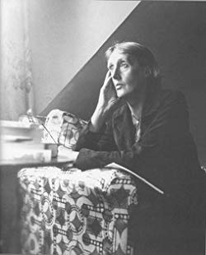

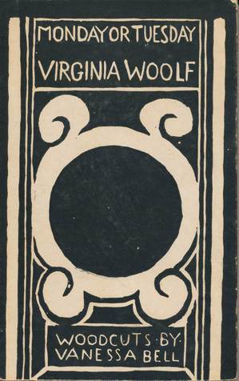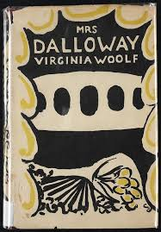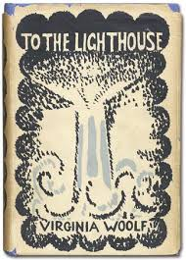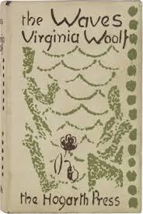

Week One: Introducing Woolf to 21st century readers

Monday November 26: Introduction. Assign stories from *Monday or Tuesday* “: An Unwritten Novel.” “Kew Gardens.” “A Mark on the Wall” and project.

Assign essays, “Character in Fiction” and “Modern Fiction.”

Read sections in *A Writer’s Diary* through 1921.

Tuesday November 27: “An Unwritten Novel.” “Kew Gardens.” “A Mark on the Wall.” Go over project.

Wednesday November 28: *Monday or Tuesday* continued.

Read AROO Chapters 1-3 and *A Writers Diary* 1929.

Thursday November 29: *A Room of One’s Own*.

Read AROO Chapters 4-6

Friday November 30: *A Room of One’s Own*

WEEKEND

SATURDAY December 1

SUNDAY December 2

WEEK TWO

Monday December 3: *Mrs Dalloway*

Read *A Writers Diary* 1923-5.

Tuesday December 4: *Mrs Dalloway*.

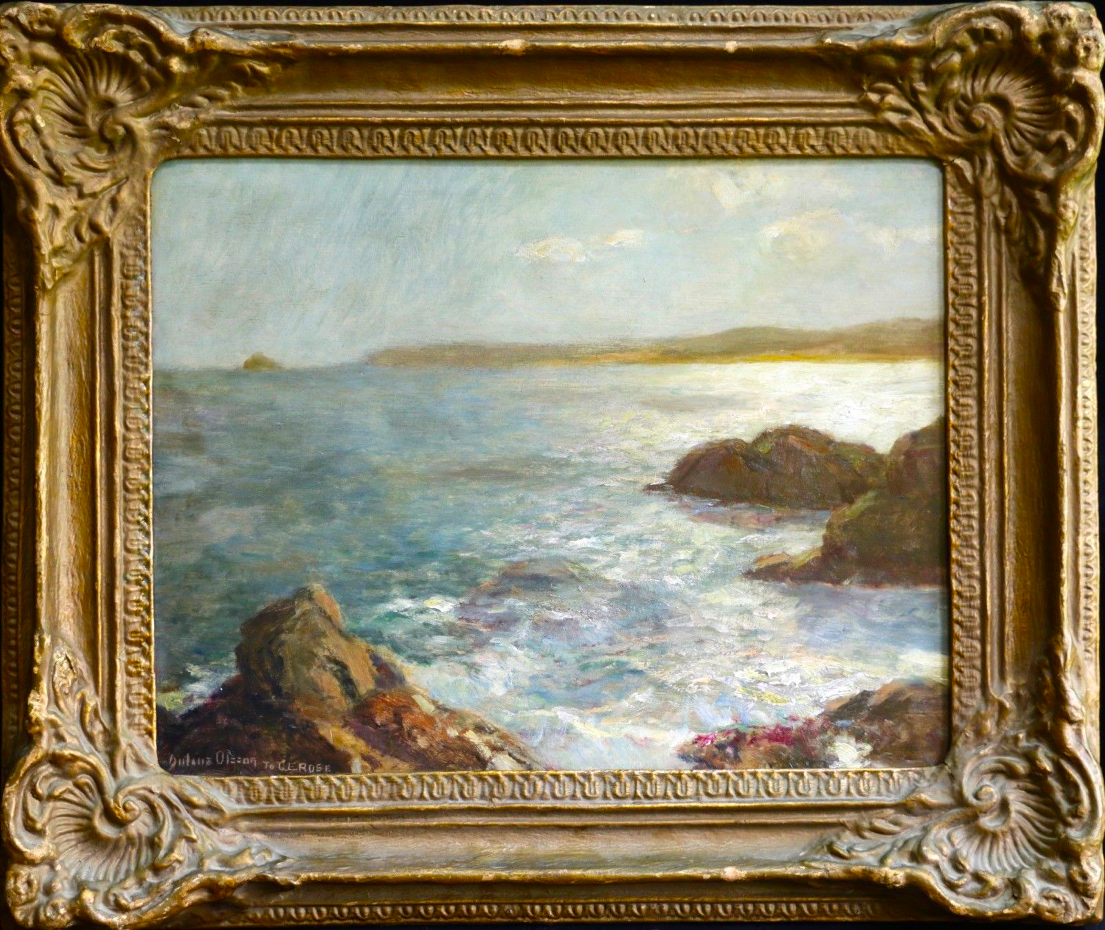

Wednesday December 5: “A Sketch of the Past” and Part 1 of *To the Lighthouse*

Read *A Writer’s Diary* 1926-7

Thursday December 6: *To the Lighthouse*

Friday December 7: *To the Lighthouse.*

MIDTERM Take Home Essays due noon Saturday.

WEEKEND

SATURDAY December 8

SUNDAY December 9

WEEK THREE:

Monday December 10: *Orlando*

Read *A Writer’s Diary* 1927-8

Tuesday December 11: *Conferences about Student Symposium Projects*

Wednesday December 12: *Orlando*

Thursday December 13: *The Waves*

Read *A Writer’s Diary 1929-31.*

Friday December 14: *The Waves*.

Final exam Take home due Saturday noon.

WEEKEND

SATURDAY December 15

SUNDAY December 16

WEEK FOUR:

Monday December 17: Workday. Conferences as needed.

Tuesday December 18: Student Symposium Presentations I.

Presentations geared towards Student Symposium model. (Read aloud paper of 15 minutes)

Wednesday December 19: Student Symposium Presentations II.

Celebration.

**Projects & Grading**

**Daily Quizzes/Freewrites on Reading and other daily expressions. 25%**

**Take Home Essays/Short Essays Midterm. 5 page minimum. 250%**

**Take Home Essays/Short Essays Final. 5 page minimum. 25%**

**Student Symposium Project: Critical or Creative or Both. 5-7 pg critical paper with Works Cited or art project with 5 page Artists Statement with Works Cited. 25%. Presentations for Student Symposium would include an abstract and a paper to be read aloud for 15 minutes. Powerpoint and other visual options can be created.**

**GRADE STANDARDS and Guidelines** It is important to acknowledge that students earn their grades in college. They are not something the professor “gives” you. You may earn an A or an F or something in between; it depends upon your achievements, which often reflect your effort, though you are not graded for effort alone. You are expected to put solid intense effort into every course on the block plan, and to hand in all work at an acceptable level. You may not pass the course if you are missing ANY assignments. You may fail the course with 2 or more absences. You cannot pass without doing all the work at a passing level, and you are expected to challenge yourself.

You may earn an F for poor or missing work, failure to carry your share of the load, plagiarism, absences, etc.

You may earn a D for slack or poor work that does not come up to the standard expectations.

You may earn a C for doing all the work, understanding all the readings, and contributing solid good work that is at the level of basic expectations for a demanding college course.

You may earn a B for very good work that exceeds expectations and demonstrates intellectual engagement, thorough understanding of all the readings and materials, and solid, positive contributions to class.

You may earn an A for superb work that excels beyond expectations and demonstrates impressive intellectual engagement, outstanding understanding of all readings and materials, and creative and dazzling initiative.

**Information on general Cornell College policies & English 347:**

* 1. Cornell College expects all members of the Cornell community to act with academic integrity. An important aspect of academic integrity is respecting the work of others. A student is expected to explicitly acknowledge ideas, claims, observations, or data of others, unless generally known. When a piece of work is submitted for credit, a student is asserting that the submission is her or his work unless there is a citation of a specific source. If there is no appropriate acknowledgement of sources, whether intended or not, this may constitute a violation of the College’s requirement for honesty in academic work and may be treated as a case of academic dishonesty. The procedures regarding how the College deals with cases of academic dishonesty appear in The Catalogue, under the heading “Academic Honesty."
  2. Students with disabilities:  
     Students who need accommodations for learning disabilities must provide documentation from a professional qualified to diagnose learning disabilities. For more information see [http://cornellcollege.edu/disabilities/documentation/index.shtml](http://www.cornellcollege.edu/academic-support-and-advising/disabilities/documentation/index.shtml)Students requesting services may schedule a meeting with the disabilities services coordinator as early as possible to discuss their needs and develop an individualized accommodation plan. Ideally, this meeting would take place well before the start of classes.  
       
     At the beginning of each course, the student must notify the instructor within the first three days of the term of any accommodations needed for the duration of the course.

Meeting Cornell College Educational Priorities:

The English 335 course meets these objectives and more:

* *In both written and verbal form, effectively articulate, evaluate and critique various production concepts using professional language, theory and standards. (Communication, Reasoning)*
* *To develop and hone skills for reading and writing about challenging texts. (Inquiry, Communication, Reasoning)*
* *See below for more information*

| **Educational Priorities** | **Students will…** |
| --- | --- |
| **Knowledge** | integrate and apply knowledge from a focused area of study as well as a broad general education which includes disciplinary and interdisciplinary perspectives in the arts, humanities, sciences, and social sciences. |
|  | Literature, Visual Arts, Cultural Studies aspects of studying Virginia Woolf |
| **Inquiry** | respond to the complexities of contemporary and enduring problems using information literacy tools, research skills, creative thinking, and analysis. |
|  | Research and preparing Student Symposium presentations |
| **Reasoning** | evaluate evidence; interpret data; and use logical, mathematical, and statistical problem-solving tools. |
|  | Close reading of texts develope interpretative skills |
| **Communication** | speak and write clearly, listen and read actively, and engage with others in productive dialogue. |
|  | Writing daily about the readings |
| **Intercultural Literacy** | connect with diverse ideas and with people whose experiences differ from their own and that may be separated from them by time, space, or culture. |
|  | We learn about 20th c British culture |
| **Ethical Behavior** | recognize personal, academic, and professional standards and act with integrity. |
|  |  |
| **Citizenship** | collaborate with others and contribute in their communities and the larger world. |
|  |  |
| **Vocation** | discover and prepare for the range of opportunities and challenges that await them beyond their college experience. |
|  | Forging an intellectual community and working with others in productive ways build key skills. |
| **Well-Being** | respect the ways physical, emotional, spiritual, and intellectual well-being may contribute to a balanced life. |

